**AW 11 Final Exam Review**

**Investing Money: Simple and Compound Interest.**

**Formulas: Simple Interest I = Prt Compound Interest: **

**A** = amount of money accumulated after n years, including interest.

**P** = principal amount (the initial amount you borrow or deposit)

**r**  = annual rate of interest (as a decimal)

**t**  = number of years the amount is deposited or borrowed for.

**n**  =  number of times the interest is compounded per year

**Example:**  David invests $1500 in a GIC for 2 years. The interest rate is 2.5% compounded quarterly. Calculate the interest.

Solution: 

= 1500 (1 +

=$1576.66

Total interest = A – P = 1576.66 – 1500 = $76.66

**I** = interest paid

**P** = principal amount (the initial amount you borrow or deposit)

**r**  = annual rate of interest (as a decimal)

**t**  = number of years the amount is deposited or borrowed for.

* Can also be rearranged, eg.

P =  t =  r = 

**Example:**  David invests $1500 in a GIC for 2 years. The interest rate is 2.5% per year. Calculate the interest.

Solution: I = Prt

= 1500 x 0.025 x 2

= $75

The intere

**Solut**

1. If $2000 was deposited in an account with an annual simple interest rate of 4% for 5 years, how much interest was earned?

ANS:________________

2. Tiffany has invested $1540 in a savings account which offers 2.4%/yr. After a period of time, she had earned $50.25 in simple interest. How long was her money invested for?

ANS:________________

3. Ava has invested in a savings account which offers 2%/yr, simple interest. After 1 year, she has earned $.75 in interest. How much money did she invest?

ANS:________________

4. Tomas has 5 years to make $200 in simple interest. If he has $2000 to invest, what interest rate will Tomas need?

ANS:________________

5. Catalina is looking to make $1000 in interest. She is currently investing $3450 in an account that pays an annual simple interest rate of 5%. She plans to invest for 5 years. Will she make $1000 in interest? Show your work.

ANS:________________

6. Kyle has decided to invest $10 000 in his savings account, which offers 2% annual simple interest. He will be investing his money for 10 years. How much more interest could Kyle earn if the 2% interest was compounded annually? Show your work.

ANS:________________

7. Derek owes $756.88 on his credit card. He makes the minimum monthly payment of $30.00. The card has an APR of 18.99% and is compounded daily. How much will Derek owe on his card in 30 days?

ANS:________________

8. Hanna is lending Logan $767.54 to buy a computer. Hanna charges simple interest at 7.2%/yr. At the end of 5 years, Logan will repay Hanna. How much will Logan owe?

**Managing Money**

9. List three services offered by banks. _________________________________________

10. Kit is looking to set up a new chequing account. She has the choice between the following accounts. Which will cost her the least if she keeps a minimum balance of $1500, and plans to make 30 transactions? Show your work.

Answer:

|  |  |  |  |
| --- | --- | --- | --- |
|  | **Account 1** | **Account 2** | **Account 3** |
| *Monthly fee* | $4.00 | $8.00 | $16.00 |
| *No fee with min. balance of ...* | $1000 | $2000 | $3000 |
| *Number of free transactions* | 10 | 25 | no limit |
| *Additional transaction fee* | $0.70 | $0.70 | __ |

11. When might you not want to use your debit card, and why? _______________________________

_______________________________________________________________________________

12. List 2 purposes of a debit card. __________________________________________________

13. What are the advantages of a credit card?_______________________________________________

14. Bob received a credit card statement that has a new balance of $1080.96 and a minimum payment

of $50.40. Bob makes only the minimum payment. He makes no other purchases. What will be

the unpaid balance?

Answer:_____________________________

15. List 3 services offered by online banking. ____________________________________________

16. What is collateral? _____________________________________________________________

**Working with Graphs:**

17. The following graph shows the population of raccoons and chipmunks in a small residential area in British Columbia.

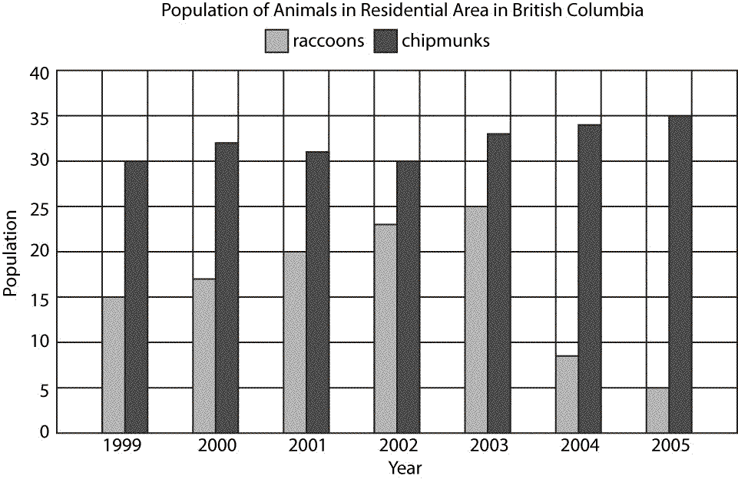

Describe the trend of the raccoon population.__________________________________________

______________________________________________________________________________

______________________________________________________________________________

18. The following graph shows the minimum hourly wages in Canadian provinces and territories, as of May 1, 2011.

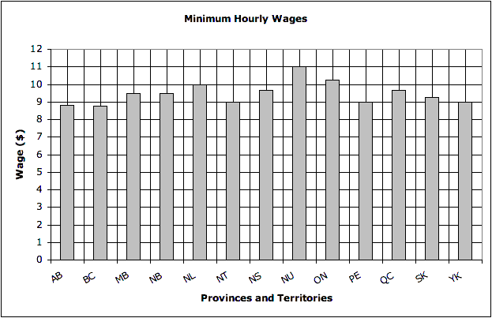

Which territory or province has the highest hourly minimum wage?

_____________________________________________________

19. A hot water tank is dripping at a constant rate, and the amount of water in the tank is represented by this graph.

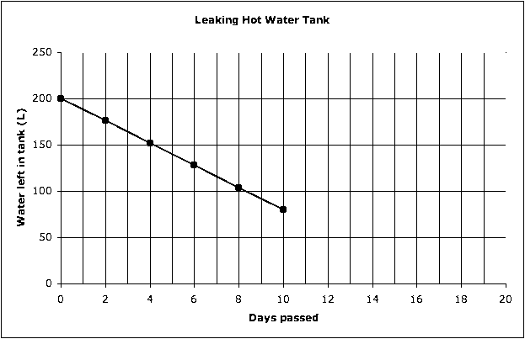

Extend the line to determine how many days must pass until the tank is empty. ANS_____________

20. Katie discovered that her water tank was leaking at a constant rate. She collected this data.

|  |  |
| --- | --- |
| **Days passed** | **Water left in tank (L)** |
| 0 | 180 |
| 2 | 158 |
| 4 | 136 |
| 6 | 114 |
| 8 | 92 |
| 10 | 70 |

**a)** Create a line graph using this data.

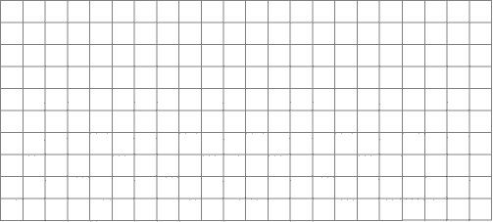

**b)** How much water will be in the tank after 9 d? Ans:___________________

**c)** After how many days will the tank be empty? Ans:___________________

21. Maureen recorded her expenditures from the last month. Create a circle graph to display the data.

Draw your circle graph here

|  |  |
| --- | --- |
| **Expenditure** | **Amount** |
| Necessities | $2400 |
| Non-necessities | $2160 |
| Savings | $240 |

|  |  |  |  |  |
| --- | --- | --- | --- | --- |
| Expenditure | Fraction | Decimal | Degrees | Percent |
|  |  |  |  |  |
|  |  |  |  |  |
|  |  |  |  |  |

22. What would be the best type of graph to show how many students in a class like certain types of ice cream? Justify your answer.

Ans:________________________________________________________________________

23. What would be the best type of graph to show the most common range of average temperatures from a month?

Ans:___________________________

24. Haddie collected data about the population of British Columbia over the past 30 years.

|  |  |
| --- | --- |
| **Year** | **Population** |
| 1981 | 2 744 467 |
| 1986 | 2 883 370 |
| 1991 | 3 282 061 |
| 1996 | 3 724 500 |
| 2001 | 3 907 738 |
| 2006 | 4 113 487 |

Create a bar graph based on this data, and predict the population for 2011.



**Surface Area:** The total area of the surfaces of a three-dimensional object. Answer will be in square units, eg cm². Formulas are generally used to calculate surface area.

**USE THE FORMULA SHEET TO ANSWER THE FOLLOWING QUESTIONS .**

**Copy the formula carefully and then substitute values. Show all your work.**

|  |  |
| --- | --- |
| 25.  a) Draw a net for the following rectangular prism  AND record the dimensions on the net.    b) Determine the surface area | 26. Draw a net for the following cylinder AND record  the dimensions on the net.    b) Determine the surface area to one decimal place. |

|  |  |
| --- | --- |
| 27. What is the surface area of the rectangular prism for this net? | 28. What is the surface area of the cylinder for this net,  to one decimal place? |
| 29. Determine the surface area of the following prism. | 30. Determine the surface area of the pyramid below. |

|  |  |
| --- | --- |
| 31. Determine the surface area of the cone below, to two decimal places. | 32. Determine the surface area of the following sphere,  to the nearest tenth of a square inch. |

|  |
| --- |
| 33. Gloria makes toy for her children, including wooden blocks which she paints. Which of these two designs  will be less expensive to paint? |

**Volume and Capacity:**  **Volume** is the amount of 3-dimensional space an object occupies. Answers will be in cubic units eg. *Metric:* cubic centimeters (cm3), cubic meters (m3) or *Imperial:* cubic inch, cubic foot.

**Capacity** is the amount that something can hold and is measured in litres, gallons, pints, For example: "The bucket has a capacity of 9 litres”

**Example**: Calculate the volume of the rectangular prism with length of 12 cm, width 2 cm and height 2 cm.

**Solution**: Volume of 3d object is Area of base x Height

The base is a rectangle – area of rectangle is l x w, so

Area of rectangular prism is l x w x h

12 x 2 x 2 = 48cm³

|  |  |
| --- | --- |
| 34. What is the volume of this cylinder, to the nearest cubic inch?  What is | 35. What is the volume of this prism, to the nearest cubic centimeter? |

|  |  |
| --- | --- |
| 36. What is the volume of this pyramid, to the nearest cubic centimeter? In cubic metres to 6 decimal places? | 37. What is the volume of this prism, to the nearest cubic inch? |
| 38. What is the volume of this cone, to two decimal places? | 39. David works in a skateboard shop. Stainless steel balls are inside each wheel bearing. What is the volume of each ball bearing, to the nearest cubic millimeter? |

|  |  |  |
| --- | --- | --- |
| |  |  | | --- | --- | | 41. Andy, a water boy, has 250 cone drinking cups for football players at a big game. Each cup has a diameter of 84 mm at the top and a height of 102 mm. Calculate the volume of carbonated water needed to completely fill the 250 cups. Round up to the nearest liter. | 42. The storage area in a building has a volume of 7843.64 . The boxes for the storage area are rectangular prisms. Each has the dimensions 18.095m by 1.675 m by 3.423 m. What is the maximum number of boxes than can fit into the storage area |   40. What is the volume of the given object, to the nearest cubic metre? |

**Drawing 3D Objects and Shapes**

43. Make an isometric drawing of this structure.

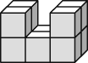 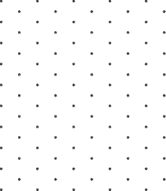

44. From this isometric drawing, draw the top, front and right-side views.

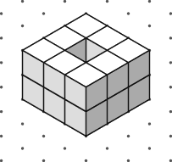

45. Draw a one-point perspective drawing of a triangular prism. Include the horizon line and vanishing point.

46. The following picture is an exploded view of a stool.

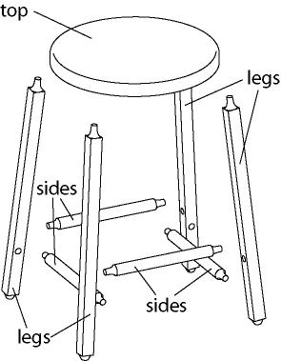

Draw a freehand sketch of the stool when assembled.

Drawing:

47. Draw an exploded view of this computer desk.

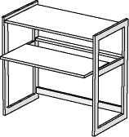

48. Jon wants to build a birdhouse with these pieces. Draw a picture of the assembled birdhouse.

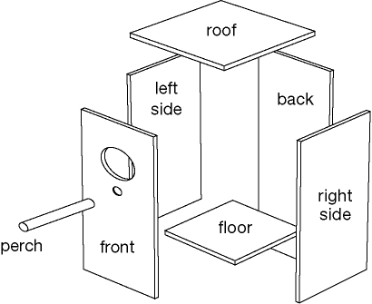

Drawing:

49. Geoff wants to build a model of a building that is 100 m tall, Answer:_________________

85 m wide, and 90 m long. What could be the measurements of Geoff’s scale model?

50. Draw a scale diagram of this living room floor plan on grid paper, and show the scale.

